**Summer Project Report (2017)**

**Project Title:**

**Develop an online System to host capture the flag contest and hackathons**

Under

**Center of Excellence in Cyber Systems and Information Assurance (CoE-CSIA), IIT Delhi**

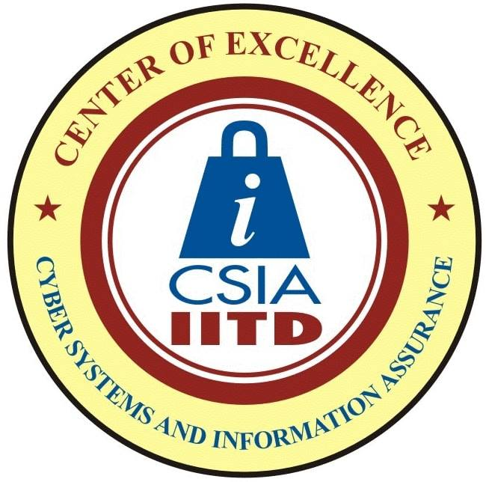 

**Duration: 15th May, 2017 to 14th July, 2017**

**Team Members:**

|  |  |
| --- | --- |
| **Name** | **Entry Number** |
| Yash Malviya | 2016CS50403 |
| Sumit Kumar Ghosh | 2016CS50400 |
| Ayush Patel | 2016CS50396 |
| Rudraksh Agarwal | 2016PH10549 |

**Supervisor: Prof. Ranjan Bose**